Year 3- Spring term project homework
This term’s project homework allows you to choose from a range of subjects and create almost anything you like! Below is a list of what we will be studying next term in specific subjects with some suggestions of activities that you could do. Choose something from the list (or come up with your own idea) that is linked to the curriculum next term and bring your project homework in by Friday 28th February
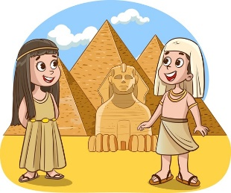  In History we will be studying The Ancient Egyptians | For your homework you could…  - Create a timeline from Ancient Egypt until now  - Compare the Ancient Egyptian’s lives with modern day lives.  - Research the Ancient Egyptians and create a poster  - Create your own Ancient Egyptian artefact
In Science we will be studying light   | For your homework you could…  - Research light and how it travels.  - Complete a light experiment.  - Create your own sun dial.
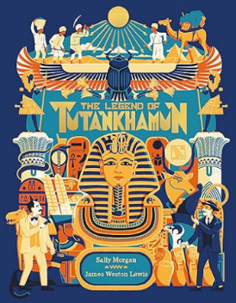  In English we will be creating a diary entry inspired by Howard Carter’s diary entries when he discovered the tomb of Tutankhamun | For your homework you could…  - Create your own diary over the half term.  - Research what features a diary entry has in it (e.g. first person, past tense).  - Find out about Howard Carter and what he discovered from the Ancient Egyptians.
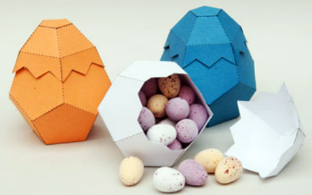  In Design Technology we will be creating an egg box from 3D nets. | For your homework you could…  - Research different egg boxes and how they are designed  - Design your own 3D nets.  - Make your own 3D shapes using nets.
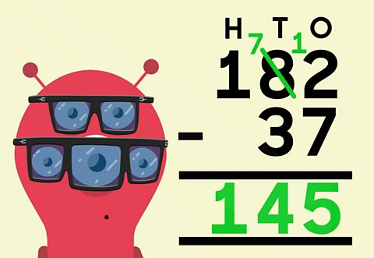  In Maths we will be working on column subtraction, fractions and our times tables. | For your homework you could…  - Make a maths game to work on your subtraction, fraction or multiplying skills.  - Create a poster to explain the rules for column subtraction.  - Research the difference between ¼, ½ and ¾ and show this as a poster.

