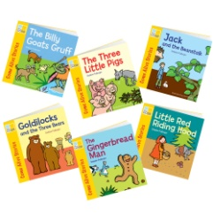

Dates for your Diary;
6/01/25 First day of Term.
13/01/25 – Reception vision tests
7/02/25- Class 2 Garden Day
11/02/25 – 2.30pm Parent workshop
OUR THEME THIS TERM Traditional Tales
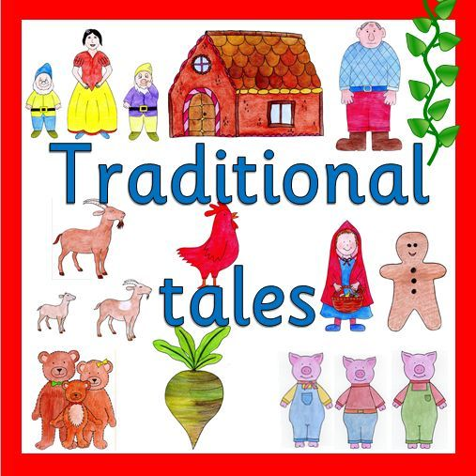
MATHS: We will be subitising with numbers up to 6. We will be recognising and ordering numbers 1-5 and looking at one more than 5. We will be learning how numbers are composed and look at part, part, whole. We will look at how numbers to 7 are made up using a double dice frame. We will also be finding out about 3D shapes and their properties and using positional language.
LITERACY/COMMUNICATION AND LANGUAGE
We will be responding to stories and using story book language and introducing storylines into our play. Some of the stories that we will be reading are; Little Red Riding Hood, The 3 Little Wolves and the Big Bad Pig, The Magic Porridge Pot, The 3 Billy Goat’s Gruff , The Enormous Turnip and The Gingerbread Man. We will be continuing with Phase 3 letters and sounds, please look in the front of your reading diaries. Check the class webpage and whiteboard for when new graphemes are taught.

HOW CAN YOU HELP YOUR CHILD?
Read to your child regularly and ask them to re-tell the story.
Support them to blend the letter sounds they know together.
Play number games, concentrating on numbers to 5 and 10
Estimate how many things you can see and then check by counting with careful 1:1 correspondence.
Physical Development
We will be practising our letter formation and developing our balance using large scale obstacles.
We will be looking at how to transport and use things safely.
Personal, Social and Emotional Development
.
We will be learning how to be sensitive to others’ needs and feelings.
We will be building our confidence to talk in familiar groups.


Understanding the World
We will be looking at festivals throughout the half term – Valentine’s Day and Chinese New Year and the season of Winter.

We will be looking at similarities and differences in locations from Traditional stories.

Expressive Arts and Design
We will be singing, dancing and acting to do with our topic. We will be looking at building and joining using tools and techniques.

Our Skill for Success this term is
Responsibility
HOMEWORK: 10-15 minutes of daily reading, including tricky words and letter sounds labelled ‘Phase 2 &3’ . Use the Phase 2 & 3 letter cards sent home with your child to make words – alien and real.

