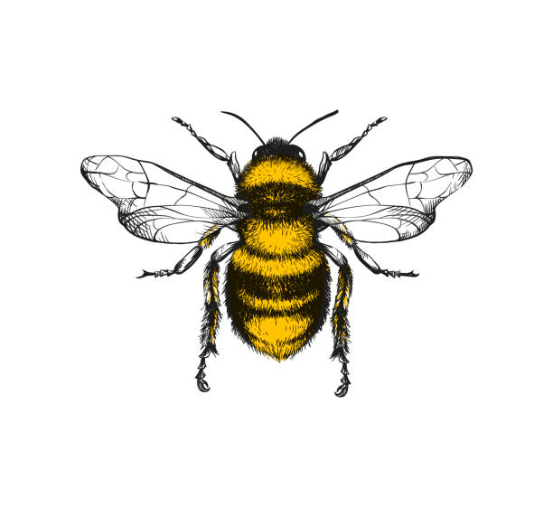

21. Build independently with a range of appropriate resources.

20. Try a wider range of foods with different tastes and textures.

4. Fit themselves into spaces, like tunnels, dens and large boxes, and move around in them.

3. Clap and stamp to music.

8. Explore different materials and tools. (Playdough, real tools, hammers)

7. Show an increasing desire to be independent, such as wanting to feed themselves and dress or undress.

5. Use large and small motor skills to do things independently, for example attempts to do zips, and pour drinks.

6. Holds mark making tools with thumb and all fingers.

10 Develop manipulation and control-one-handed tools and equipment, for example, making snips in paper with scissors or a knife to spread jam.

9. Start eating independently and learning how to use a knife and fork

19. Able to build independently with a range of appropriate resources (Both large or small scale structures with loose parts).

19.. Kicks a stationary ball with either foot

18. Throws a ball with increasing force.

13. Continue to develop their movement, balancing, riding (scooters, trikes and bikes) and ball skills.

15 Beginning to match their developing physical skills to tasks and activities in Nursery. For example, they decide whether to crawl, walk or run across a plank, depending on its length and width..

14. Use large muscle movements to wave flags and streamers, paint and make marks.

12. Starts to catch a large by using two hands and their chest to trap it.

17.. Skip, hop, stand on one leg and hold a pose for a game like musical statues.

16. Go up steps and stairs, or climb up apparatus, using alternate feet

11. Beginning to recognise danger and seeks support of significant adults for help.

2. Beginning to develop manipulation and control. (through playdough, threading, puzzles etc.)

1. I have gained control of mywhole body through continual practice of large movements, such as waving, kicking, rolling, crawling and walking.

**Physical Development**