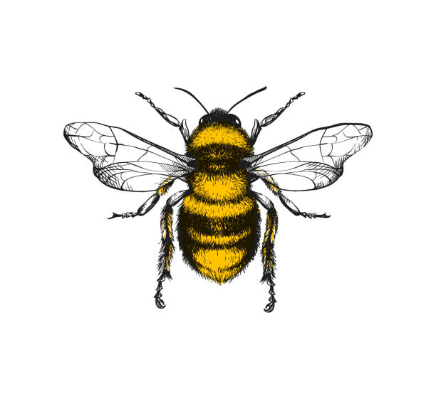

19. I respect living things and know how to take care of the school guinea-pigs and how to handle them safely.

18 I am beginning to understand seasons and enjoy looking at artefacts found during Autumn, Winter, Spring and Summer

3. *Talk about the differences between materials and changes they notice. (Snow, Ice melting)

17. Notice differences between people.

15 Explore and respond to different natural phenomena in Nursery. E.g. standing in the rain with wellies and umbrellas, jumping in puddles, bugs, local walks etc

4. 20. Beginning to explore natural materials, indoors and outside.(curiosity, loose parts natural thinkers)

8. Notice differences between people. (culture, family days/ photos)

7. Beginning to plant seeds and care for growing plants.

5. Show interest in different occupations i.e. doctors, postman, refuse collectors.

6. Explore collections of materials with similar and/or different properties.

10. Able to talk about what they see, using a wide vocabulary.

9. Explore how things work. (problem solving & science experiments)

13. Make connections between the features of their family and other families.

12Beginning to use all their senses in hands-on exploration of natural materials (curious to explore and make own choices).

16. I use my fingers, feet and whole body to explore different textures e.g. wet and dry sand, water, paint and playdough.

11.. Plant seeds and care for growing plants. (showing respect for the natural world)

2. Explore materials with different properties.

1. Repeat actions that have an effect. (Exploring how things work)

**Understanding of the World**