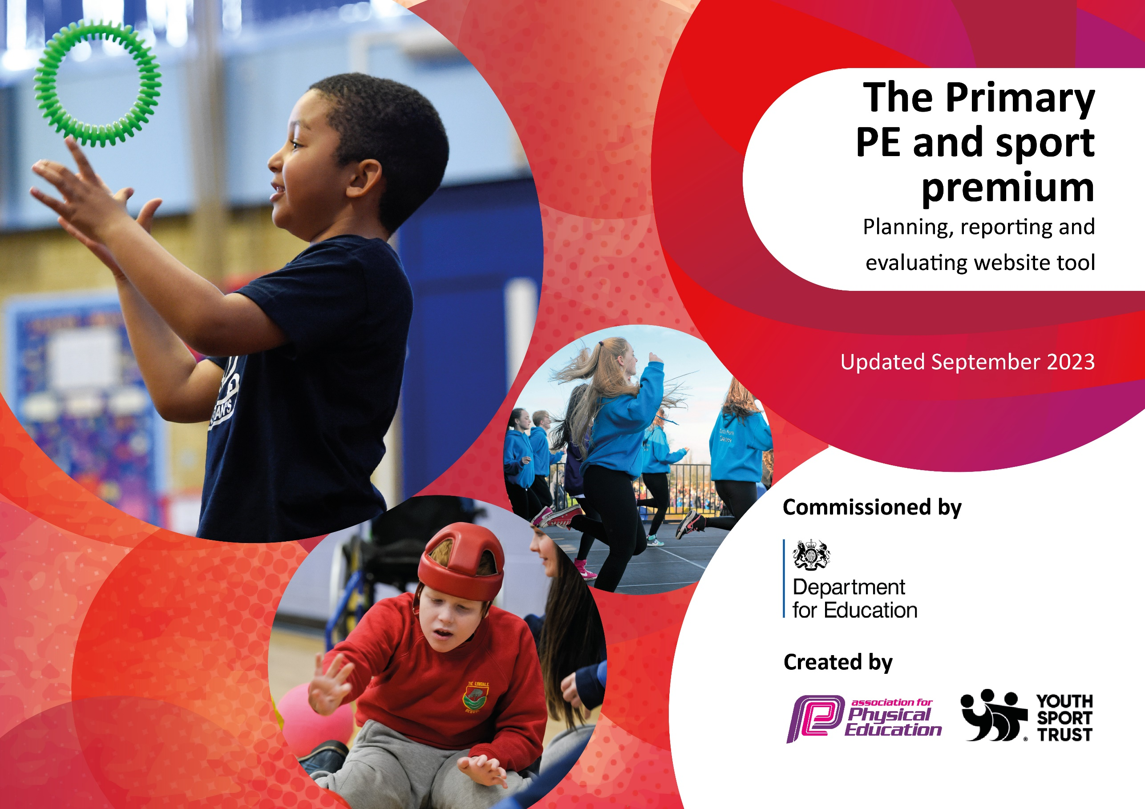

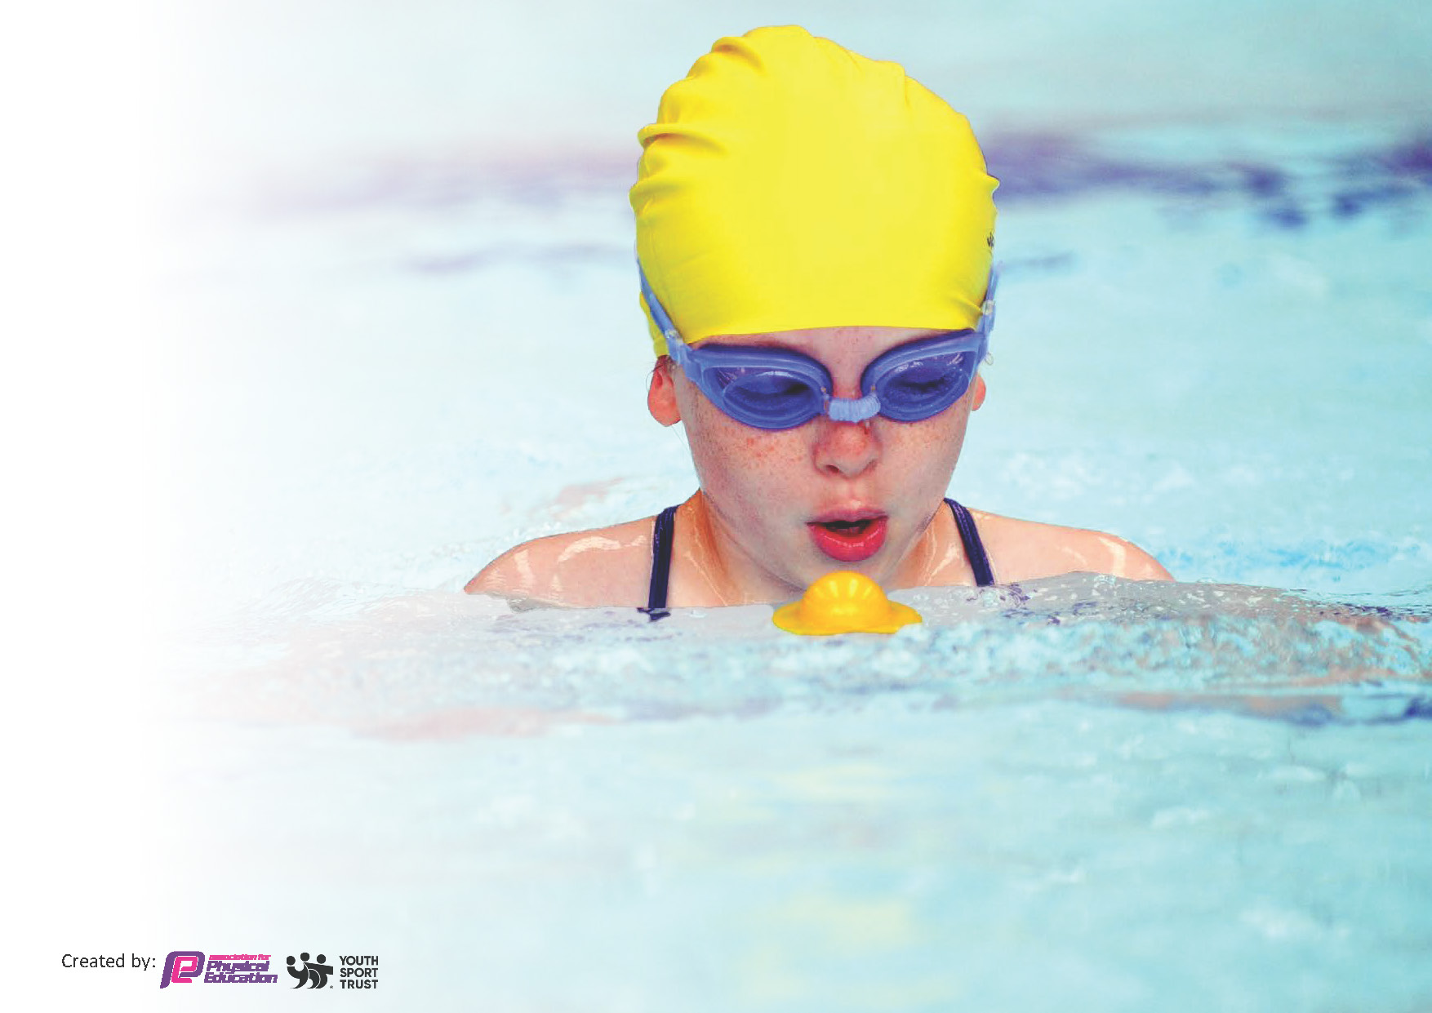
This template can be used for multiple purposes:
by:
- It enables schools to effectively plan their use of the Primary PE and sport premium
- It helps schools to meet the requirements (as set out in guidance) to publish information on their Primary PE and sport premium
- It will be an effective document to support Ofsted inspections enabling schools to evidence progress in Physical Education (PE) and evidence swimming attainment, which forms part of the PE National Curriculum. We would recommend schools consider
the Intent, Implementation and Impact of any spend, as examined within the Education Inspection Framework.

It is important that your grant is used effectively and based on school need.

Schools must use the funding to make additional and sustainable
improvements to the quality of the PE, School Sport and Physical Activity (PESSPA)
they offer. This means that you should use the Primary PE and sport premium to:

- Build capacity and capability within the school to ensure that improvements made now will benefit pupils joining the school in future years
- Develop or add to the PESSPA activities that your school already offers.

The Primary PE and sport premium should not be used to fund capital spend projects; the school’s core budget should fund these. Further detail on capital expenditure can be found in the updated Primary PE and sport premium guidance.

The Primary PE and sport premium guidance, outlines 5 key priorities that funding should be used towards. It is not

necessary that spending has to meet all the key priorities, you should select the priorities that you aim to use any funding towards.

Although completing this template is not a requirement for schools, schools are required to publish details of how they spend this funding. Schools must also outline what the impact this funding has had on pupils’ PE and sport participation and attainment and how any spending will be sustainable in the future. All funding must be spent by 31st July 2024.

The Department for Education has worked closely with the Association for Physical Education (afPE) and the Youth Sport Trust (YST) to develop this template and encourages schools to use it. This template is an effective way of meeting the reporting requirements of the Primary PE and sport premium.
Review of last year’s spend and key achievements (2022/2023)

We recommend you start by reflecting on the impact of current provision and reviewing your previous spend.

Activity/Action | Impact | Comments
Increase opportunities for pupils to participate in activities across the school day. External providers to provide PE twice weekly across a range of year groups  Recognise sporting achievements of pupils and staff. Promote participation in sport to encourage pupils to think about lifestyle choices. Introduce more competitive lunchtime activities that will encourage children to take part  Ensure all pupils, including SEND/ vulnerable/ less active and more able have equal opportunities to participate in sport. Provide opportunities for staff to further their knowledge and delivery of some sport  Additional achievements: A range of after school clubs lead by staff or external providers, offering more a more diverse range of sporting activities Signpost children to local clubs and half term/holiday camps Ensure all children are able to swim confidently, competently and proficiently the recommended distance of 25m  Ensure all pupils, including SEND/ vulnerable/ less active and more able have equal opportunities to participate in local competitions | Optimum Sports and Coaching was employed twice a week to plan and deliver PE sessions for all year groups, varying in sports and activities, exposing children to a variety of sports.  Website and PE board is updated with pictures of children’s sporting success, as well as celebrated in assemblies and classes. Staff likewise. Children feel valued and that they have been recognised for their successes.  PE lessons are adapted to ensure that all children can access at some level. External providers such as Optimum Sport and Coaching have given staff excellent ideas on how to adapt PE sessions and sports to enable participation for all and staff can now use this in their own practice.  Clubs such as Frisbee, tri-golf, gymnastics have been lead by external providers, whilst staffs also run football, rugby, cricket, and athletics. Local club posters are put on the newsletter and up for parents to see to encourage participation. Regular swimming lessons in Autumn and Summer term helped 75% of children to swim the recommended 25m.  Staff are encouraged to include all children when picking for events/competitions and equal opportunities are given to children, regardless of ability, ensuring that we are as inclusive as possible. Where there are SEND specific events, OCRA deliver sessions at our school for these children. | The use of a high quality external provider has been beneficial for children in terms of experiencing new sports, learning new skills and having more internal competitions amongst classes and year groups. It has been beneficial for staff in terms of giving us ideas on assessment, how to plan and deliver effective PE lessons and being adaptive and responsive during these lessons.  Children are more encouraged to share their sporting achievement with their class and the school.  Swimming remains good – Parents need to ensure their child is attending regular swimming lessons outside of school to help pass the 25m threshold.

Key priorities and Planning
This planning template will allow schools to accurately plan their spending.

Action – what are you planning to do | Who does this action impact? | Key indicator to meet | Impacts and how sustainability will be achieved? | Cost linked to the action
Run a mile at least 3x a week and to be evidenced on teacher timetables.  Try to increase the range of sports provided at our school, e.g. Frisbee, golf. Handball  Purchase equipment to allow continuation of a range of sports to be taught effectively  Continue to develop the environmental garden by adding equipment | Children as they get to ‘Run a mile’ at least 3 times a week  Staff as they deliver these sessions  Pupils – taking part and engaging in different and new activities  Staff – learning and delivering sports they may not have before  External providers – deliver the sessions and help to up-skill staff  Staff and pupils | Key indicator 2 -The engagement of all pupils in regular physical activity – the Chief Medical Officer guidelines recommend that all children and young people aged 5 to 18 engage in at least 60 minutes of physical activity per day, of which 30 minutes should be in school.  Key indicator 4: Broader experience of a range of sports and activities offered to all pupils. | Children will get extra Physical activity when running a mile which helps contribute towards the 60 minute daily.  More pupils meeting their daily physical activity goal, more pupils encouraged to take part in PE and Sport Activities. Staff to learn from external providers and take this forward into their practice for the future.  Equipment to enable staff and providers to teach a range of sports  Children to be provided with a useable, fun area to use at playtimes/PE times | £0  £10,992 (Optimum coaching)  £200  £2702.50

Year 5/6 top up swimming lessons  KS2 swimming lessons  Renew RealPE subscription  Participation in local sporting events and more inter school competition (house competitions/class/year group) | Teaching and support staff.  Children taking part.  Teaching and support staff.  Children taking part. | Key Indicator 1: Increased confidence, knowledge, and skills of all staff in teaching PE and sport.  Key indicator 5: Increased participation in competitive sport. | Improved numbers of children who can swim the recommended 25m by the end of KS2  Continue to aid staff in delivering high quality indoor PE sessions  Children will have more experience of competing against other schools and experiencing winning/losing. | £4,368  £695  £1800 (OCRA)

Key achievements 2023-2024
This template will be completed at the end of the academic year and will showcase the key achievements schools have made with their Primary PE and sport premium spending.

Activity/Action | Impact | Comments
Ben Jones (Optimum coaching)  OCRA | Ben has been instrumental at providing PE, especially alternative activities, to all children across our school. Children and teachers alike have benefitted from his expertise and all children have experienced a range of sports. Ben has also introduced more competition within our school.  Children have been given the opportunity to participate in a range of competitions against a range of schools. | Staff feel more up skilled due to his teaching and are more confident at teaching their own PE lessons as a result.

Swimming Data
Meeting National Curriculum requirements for swimming and water safety.
Priority should always be given to ensuring that pupils can perform safe self-rescue even if they do not fully meet the first two requirements of the National Curriculum programme of study

Question | Stats: | Further context  Relative to local challenges
What percentage of your current Year 6 cohort can swim competently, confidently and proficiently over a distance of at least 25 metres? | 74% | 2 of our children’s parents did not give permission for their children to attend catch up sessions offered to our year 6 children in the spring term. One child is new to the school and did not have the opportunity to swim with us.
What percentage of your current Year 6 cohort can use a range of strokes effectively [for example, front crawl, backstroke, and breaststroke]? | 74%

What percentage of your current Year 6 cohort are able to perform safe self-rescue in different water-based situations? | 74%
If your schools swimming data is below national expectation, you can choose to use the Primary PE and sport premium to provide additional top-up sessions for those pupils that did not meet National Curriculum  requirements after the completion of core lessons. Have you done this? | Yes | Year 6 children who couldn’t swim the 25m were offered catch up session in the Spring term.
Have you provided CPD to improve the knowledge and confidence of staff to be able to teach swimming and water safety? | No | Our swimming is lead by our local swimming pool, with qualified instructors and life guards constantly around.

Signed off by:

Head Teacher: | Laura Handel
Subject Leader or the individual responsible for the Primary PE and sport premium: | Daryl Panter – PE lead
Governor: | Matt Paige – prent governor
Date: | 23/05/24

