This term in geography, we are comparing the **human** and **physical geography** of countries in Europe to those of South America.

**Human geography** explores any human interaction or association with a place, such as population, migration, flags, man-made features, notable buildings, culture etc.

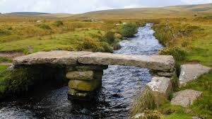 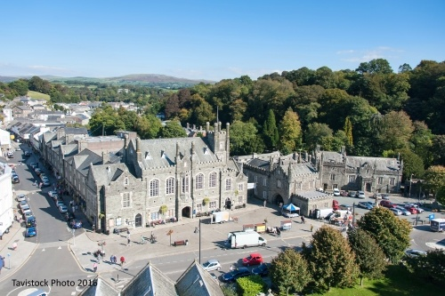

**Physical geography** explores natural features like rivers, hills and mountains and land features.

Your project this term is to do a local study of a place in Devon. Choose any place in Devon that interests you and present information about the physical and/or human geography.

You may make a model, create a PowerPoint presentation, create a book or poster. Adding photographs of your own would be particularly valuable.

Please return your project, named, to class by **Friday 28th March.**