Year 5-Spring term project homework
This term’s project homework allows you to choose from a range of subjects and create almost anything you like! Below is a list of what we will be studying next term in specific subjects with some suggestions of activities that you could do. Choose something from the list (or come up with your own idea) that is linked to the curriculum next term and bring your project homework in by Monday 24th February
In History we will be studying The Ancient Egyptians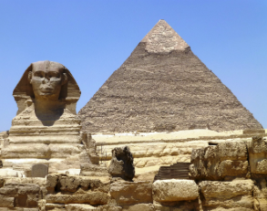 | For your homework you could…  - Compare the Ancient Egyptian’s lives with modern day lives – clothes/houses/jobs.  - Research the Ancient Egyptians and create a poster.  - Create your own Ancient Egyptian artefact  - Research Hieroglyphics and write your own message using them.  - Draw a picture or make a poster about Ancient Egypt
In Science we will be studying light   | For your homework you could…  - Research light and how it travels/what it’s used for/who invented it and why.  - Complete a light experiment.  - Create your own sun dial.  - Create a poster all about light  - Explore your home and list all the things that use light or that you use light for  (Our class assembly is also on light!)
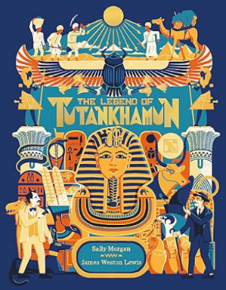  In English we will be creating a diary entry inspired by Howard Carter’s diary entries when he discovered the tomb of Tutankhamun | For your homework you could…  - Create your own diary over the half term.  - Research what features a diary entry has in it (e.g. first person, past tense).  - Find out about Howard Carter and what he discovered from the Ancient Egyptians.
  In Art we will be creating collage inspired by the work of Alma Thomas | For your homework you could…  - Research Alma Thomas and some of her work.  - Design and make your own collage.
In Maths we will be exploring factors, multiples and primes. 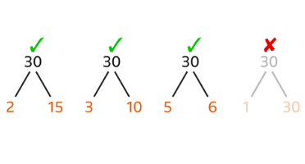 | For your homework you could…  - Explore what factors are and list the factors of some numbers  - Explore prime numbers – Top marks has lots of useful games to help you learn https://www.topmarks.co.uk/Search.aspx?q=prime+numbers

