Year 4 Project Homework
This term’s project homework allows you to choose from a range of subjects and create almost anything you like! Below is a list of what we will be studying next term in specific subjects with some suggestions of activities that you could do. Choose something from the list (or come up with your own idea) that is linked to the curriculum next term. If you would like to bring anything in to school to share, please do so by Monday 24th February.
In History we will be looking at the changes in Britain from the stone age to the Iron Age.  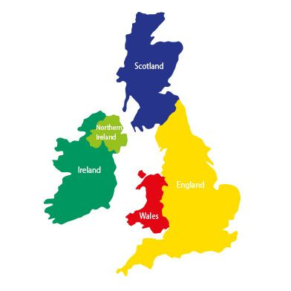 | For your homework you could…  - Name the biggest changes between these times  - Draw images of what life was like in these times  - Create a time line  - Visit somewhere in your local area that shows signs of this period in history  - Dress up like you are in the Stone Age or the Iron Age  - Research food and tools that were used in these times
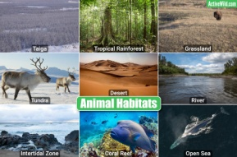  In Science we will be studying Living things and their habitats. | For your homework you could…  - Create a classification chart for animals  - Visit a woodland area and look out for signs of different types of animals  - Research the life cycle of an animal  - Create a food chain  - Explore how humans impact the environment  - Can you create a concept to pause climate change?
In English we will be sharing fiction and non-fiction books about dragons and penguins.  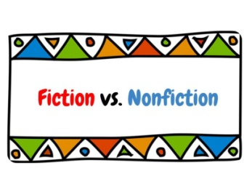 | For your homework you could…  - Visit the library and choose some non-fiction books to share  - Read some information books about things you are interested in  - Collect some facts about something you are interested in  - Create your own Dragon or Penguin fact file  - Produce your own 3D mythical creature
In Design & Technology we will be looking at secure structures and will be carrying out an egg drop challenge. | For your homework you could…  - Visit an Art gallery and see if you can see a range of art sculptures and structures  - Look around the local area – What structures can you see? How and why are they constructed differently for their purpose?  - Design your own moveable structure  - Create an edible structure
In Maths we will be working on Geometry.  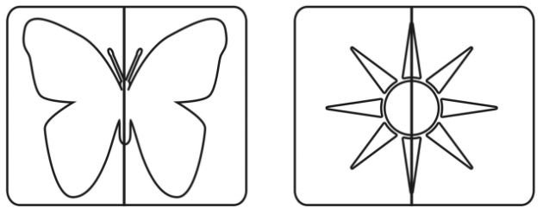 | For your homework you could…  - Explore geometric shapes in your house and the environment around you  - Explore shapes in nature  - Create a symmetrical image – Think of abstract ways you could do this  - Draw a symmetric pattern  - Continue to focus on your times tables
Please make sure you continue to read to and with your child and also listen to them read their reading book.
Please note – this homework is not mandatory however, if your child would like to carry one of more things from this suggested list, we will be having a ‘Project afternoon’ to share our learning in class.

